

The International Association of Lions Clubs
District 105D
Incorporating Lions Clubs International District 105D Charitable Trust
Registered Number 1072984

District Governor 2015 - 2016  Lion Alan Chapman

3, Beacon View, Warminster, Wiltshire BA12 8HP

 (H) 01985 216203 07808 920991  dg@lions105d.org.uk  www.lions105d.org.uk

“Teamwork with Friendship and Fellowship”

Dear Lion President, 15th February 2016

Re: Preparing and serving food at Lions events

As you may be considering an event that involves cooking or serving food I thought I would take the opportunity to issue the following reminder:

- Ask yourselves whether you need a licence from your Local Authority to serve food (i.e. do you need to be registered as a food business)? In the majority of cases this is not necessary but it is worth checking with your Local Authority, particularly if you are preparing, serving and or selling food on a regular basis.
- The Lions official position is that any food prepared, provided and / or sold should be under the direct supervision of a competent person holding a Level 2 certificate in Food Hygiene. There is an on-line training scheme available to Lions at a cost of £10.00 per person. The following link will take you to the appropriate website for more detail: http://www.saferfoodhandler.co.uk/lionsclub/ Please use the code: LIONSCLUB22 to access the Lions scheme.
- Ask yourselves if the Regulations relating to food allergens apply to your activities and ensure that you are complying? Please visit the Health & Safety pages on the District website where you will find a guidance letter issued in 2014 when the Regulations were first introduced.

- Please take a look at the ‘Road to Safety’ document on the District 105D website (page 21 onwards).

- For further guidance the following link will take you to the Food Standards Agency website and in particular to a section specifically relating to advice on providing food in a village hall or other community setting for volunteers and charity groups: http://www.food.gov.uk/business-industry/caterers/food-hygiene/charity-community-groups/

- Please remember to include your food preparation activity in your ‘event health and safety risk assessment’. The Health & Safety Executive website has a page dedicated to this subject and includes a sample risk assessment for food preparation, cooking and service. The following link will take you to the appropriate page: http://www.hse.gov.uk/risk/casestudies/foodprep.htm

Kind regards.

Sincerely,
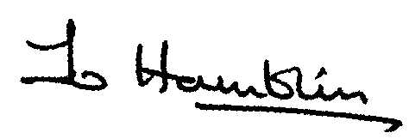
Jo Hamblin
District 105D Insurance Adviser / Risk Assessment Adviser

Distribution: Monthly District mailing.

